Ģeometrijas analīzes hierarhija

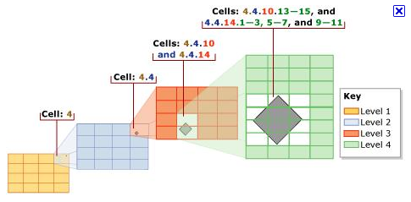

Ģeometriju indeksi

Spatial indexes are used by spatial databases (databases which store information related to objects in space) to optimize spatial queries. Indexes used by non-spatial databases cannot effectively handle features such as how far two points differ and whether points fall within a spatial area of interest. Common spatial index methods include:
1. Grid (spatial index)
2. Z-order (curve)
3. Quadtree
4. Octree
5. UB-tree
6. R-tree: Typically the preferred method for indexing spatial data. Objects (shapes, lines and points) are grouped using the minimum bounding rectangle (MBR). Objects are added to an MBR within the index that will lead to the smallest increase in its size.
7. R+ tree
8. R* tree
9. X-tree
10. kd-tree
11. m-tree - an m-tree index can be used for the efficient resolution of similarity queries on complex objects as compared using an arbitrary metric.

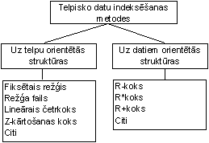
Fiksētais režģis

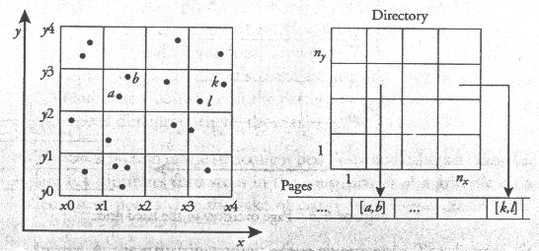

Fiksētais režģis ar pārpildes struktūru

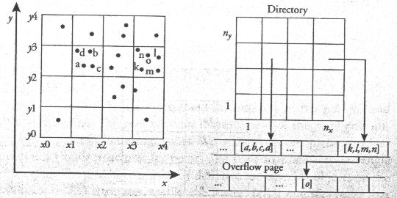

Četrkoks
Telpa tiek rekursīvi sadalīta kvadrantos, kamēr katrs kvadrants pārsedz mazāku skaitu taisnstūru par M – diska lapas ietilpība. Kvadranti tiek saukti pēc debespusēm – Ziemeļrietumu (ZR), Ziemeļaustrumu (ZA), Dienvidrietumu (DR), Dienvidaustrumu (DA). Indekss tiek attēlots kā četrdaļīgs koks (katrai iekšējai virsotnei ir četri pēcteči – katrs – vienam kvadrantam). Savukārt katra koka lapas ir saistītas ar kādu diska lapu, kas glabā indeksa ierakstus. Līdzīgi kā režģa failā, taisnstūris tiek fiksēts tajos kvadrantos, kuri to nosedz.

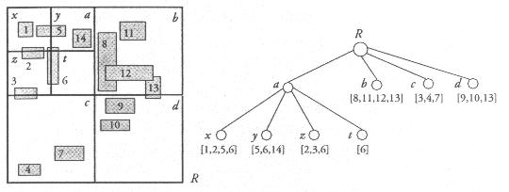
Z-secība

Z-order, Morton-order or Morton code first proposed in 1966 by G. M. Morton, is a space-filling curve which is often used in computer science: Due to its good locality-preserving behaviour it is used in data structures for mapping multidimensional data to one dimension. The z-value of a point in multidimensions is simply calculated by interleaving the binary representations of its coordinate values. Once the data are sorted into this ordering, any one-dimensional data structure can be used such as binary search trees, B-trees, skip lists or (with low significant bits truncated) hash tables. The resulting ordering can equivalently be described as the order one would get from a depth-first traversal of a quadtree; because of its close connection with quadtrees, the Z-ordering can be used to efficiently construct quadtrees and related higher dimensional data structures.

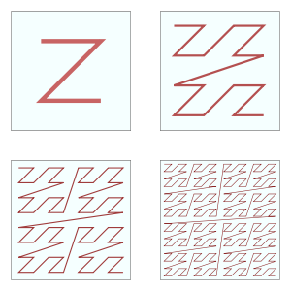

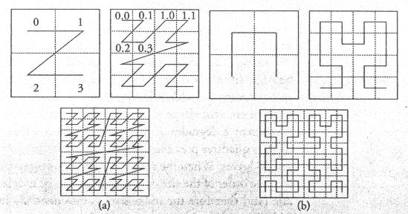
Telpu pildošās līknes: z-kārtošana (a) un Džilberta līkne (b).

Binārā telpas sadalīšana

Binary space partitioning (BSP) is a method for recursively subdividing a space into convex sets by hyperplanes. This subdivision gives rise to a representation of the scene by means of a tree data structure known as a BSP tree.

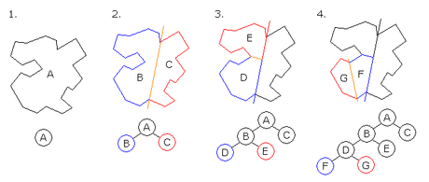
1. A is the root of the tree and the entire polygon
2. A is split into B and C
3. B is split into D and E.
4. D is split into F and G, which are convex and hence become leaves on the tree.

KD koki (k-dimensiju koki)

kd-tree (short for k-dimensional tree) is a space-partitioning data structure for organizing points in a k-dimensional space. kd-trees are a useful data structure for several applications, such as searches involving a multidimensional search key (e.g. range searches and nearest neighbor searches). kd-trees are a special case of BSP trees.
This algorithm creates the invariant that for any node, all the nodes in the left subtree are on one side of a splitting plane, and all the nodes in the right subtree are on the other side. Points that lie on the splitting plane may appear on either side. The splitting plane of a node goes through the point associated with that node (referred to in the code as node.location).
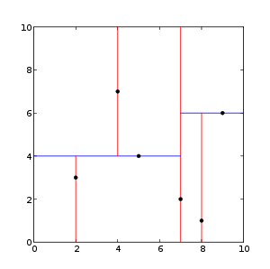
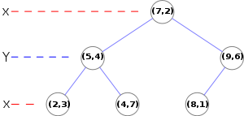
The resulting kd-tree.

OCT koki (OCTTree)

An octree is a tree data structure in which each internal node has exactly eight children. Octrees are most often used to partition a three dimensional space by recursively subdividing it into eight octants. Octrees are the three-dimensional analog of quadtrees. The name is formed from oct + tree, and normally written "octree", not "octtree".

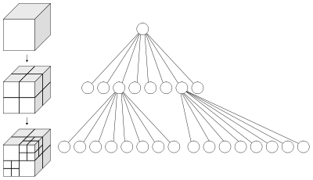
Left: Recursive subdivision of a cube into octants. Right: The corresponding octree.

R koki (Rectangle trees)

R-trees are tree data structures that are similar to B-trees, but are used for spatial access methods, i.e., for indexing multi-dimensional information; for example, the (X, Y) coordinates of geographical data. The data structure splits space with hierarchically nested, and possibly overlapping, minimum bounding rectangles (MBRs, otherwise known as bounding boxes, i.e. "rectangle", what the "R" in R-tree stands for).

